Contents

Abstract: 3

Introduction: 3

Significance of Efficient Customer Flow Management: 3

Current Process: 3

Objectives: 4

Background: 4

Description of the System 4

Type of Business 4

Operation Hours: 4

Methods: 5

Data Collection (Data Input): 5

Flow Chart of the Model: 5

Assumptions 7

Initial State of the System 8

Arena Model 10

Results 15

Data output 16

Discussion 18

Discussion of the results 18

Suggestions for improvement 19

Conclusion 20

Practical implications 20

# Abstract:

This project focuses on enhancing Dunkin' Donuts' operational efficiency by optimizing customer flow management. Utilizing Arena simulation modeling, we address challenges such as long wait times and operational bottlenecks during peak hours. The study explores key objectives, including minimizing billing counter wait times, improving beverage counter efficiency, and optimizing staff utilization. By employing data-driven insights and simulation results, the project provides strategic recommendations for process improvements. The findings aim to guide Dunkin' Donuts in delivering a seamless and satisfying customer experience.

# Introduction:

In the fast-paced and competitive landscape of the fast-food industry, the seamless management of customer flow is a critical factor that directly influences operational efficiency and customer satisfaction. Recognizing this, our graduate-level project aims to address the challenges faced by Dunkin' Donuts stores in managing customer flow through the application of advanced simulation techniques, specifically utilizing the Arena simulation model. This introduction provides an overview of the project, outlining its significance, objectives, and potential impact on the operational dynamics of Dunkin' Donuts stores.

## Significance of Efficient Customer Flow Management:

Efficient customer flow management is imperative in the fast-food industry, where timely service and a positive customer experience are key determinants of success. Long waiting times, bottlenecks, and operational inefficiencies can negatively impact customer satisfaction, potentially leading to customer attrition and reduced profitability. Dunkin' Donuts, as a prominent player in this industry, faces the challenge of optimizing customer flow during peak hours while maintaining service quality.

## Current Process:

Dunkin' Donuts, a 24/7 establishment, faces the challenge of peak hours characterized by a surge in customer demand. The store's offerings span a diverse range of coffee and baked goods. However, the existing operational framework encounters obstacles, notably long queues at crucial service points, leading to customer discontent.

## Objectives:

1. Optimize Billing Counter Wait Times:
2. Enhance Beverage Counter Efficiency:
3. Optimal Utilization of Dunkin' Donuts Staff:
4. Identify and Mitigate Delay Factors:

# Background:

## Description of the System

Dunkin' Donuts operates as a globally recognized chain specializing in breakfast items and a diverse array of coffee beverages. Founded on the principle of delivering high-quality coffee and baked goods, the system involves a comprehensive approach to customer service. Patrons navigate through a range of offerings, from signature donuts and breakfast items to a variety of coffee drinks, all designed to provide a quick and satisfying dining experience. With an extensive menu and a commitment to convenience, Dunkin' Donuts has established itself as a prominent player in the fast-food industry.

## Type of Business

Dunkin' Donuts operates as a quick-service restaurant (QSR) with a focus on breakfast offerings and coffee-based beverages. The business model prioritizes speed, convenience, and variety, catering to individuals and families seeking a reliable and tasty option for breakfast, snacks, or coffee breaks. The co-branded approach with Baskin-Robbins in some locations showcases a diversification strategy to meet broader consumer preferences.

## Operation Hours:

Dunkin' Donuts adapts its operation hours to meet the varying needs of its customers throughout the week:

**Weekdays (Monday to Thursday):** Opens early at 5 AM, serving breakfast items and coffee throughout the day. The establishment closes at 8 PM, offering service options such as dine-in and drive-through.

**Friday:** Opens at 5 AM and closes soon at 8 PM, ensuring accessibility for breakfast and coffee items during the morning and early evening.

**Weekends (Saturday and Sunday):** Operating hours may vary, accommodating diverse weekend preferences, including breakfast, brunch, and afternoon snacks.

The provision of multiple service options, including dine-in, drive-through, and delivery, further enhances the accessibility and convenience of Dunkin' Donuts' offerings. This alignment with customer needs positions Dunkin' Donuts as a dynamic and customer-centric entity within the fast-food industry.

# Methods:

## Data Collection (Data Input):

1. **Customer Flow Data:** Simple foot traffic counts at entry points and drive-thru lanes during different hours. Manual tally or automated counters to record the number of customers entering the shop and using the drive thru.
2. **Menu Complexity:** Basic survey or observation to categorize menu items into simple and complex orders. Direct input from staff regarding popular items and average preparation times.
3. **Staffing Levels:** Daily log or records of the number of staff on duty during each shift. Employee schedules and time sheets for a quick overview of staffing.
4. **Service Times:** Stopwatch or manual timing for selected transactions at different stages (ordering, preparation, billing). Observational studies to record the time customers spend in each area.

## Flow Chart of the Model:

The Dunkin' Donuts operational flow chart delineates a streamlined process tailored for in-store ordering, ensuring a swift and satisfactory customer experience. Commencing at the "Start," patrons directly access the "Ordering Area" where they can promptly place their orders. This direct connection eliminates unnecessary steps for in-store customers, enhancing efficiency.

From the "Ordering Area," the flow chart seamlessly leads customers to the "Beverage Service Area" and the "Product Making Area." Notably, the "Beverage Service Area" offers customers the choice between self-service and staff-assisted options, empowering them with flexibility in their ordering experience.

Following the decision at the "Beverage Service Area," both paths converge at the "Billing Area," where customers settle payments, ensuring a smooth transition to the final stage – the "Exit." This concise flow chart is designed to optimize the in-store ordering process, prioritizing simplicity, speed, and customer satisfaction.

*Fig: Improved Flow Chart of Dunkin’s Operational System*

## Assumptions

Detailed Analysis of Operations with Calculations:

Table:

|  |  |  |  |  |  |  |  |
| --- | --- | --- | --- | --- | --- | --- | --- |
| Operation  Hours | Customers flow / per HR (avg) | No. Of stations | No. of operators | Customer service time (mins) | Total no. Of customers | Total Time Available (mins) | Time required to serve customers |
| 5:00 to 6:00 | 24 | 7 | 6 | 2.5 | 24 | 60 | 60 |
| 6:00 to 9:00 | 40 | 7 | 7 | 2.5 | 120 | 180 | **300** |
| 9:00 to 10:00 | 24 | 7 | 7 | 2.5 | 24 | 60 | 60 |
| 10:00 to 12:00 | 6 | 7 | 7 | 2.5 | 12 | 120 | 30 |
| 12:00 to 15:00 | 40 | 7 | 8 | 2.5 | 120 | 180 | **300** |
| 15:00 to 17:00 | 6 | 7 | 4 | 2.5 | 12 | 120 | 30 |
| 17:00 to 19:00 | 18 | 7 | 4 | 2.5 | 36 | 120 | 90 |
| 19:00 to 20:00 | 6 | 7 | 2 | 2.5 | 6 | 60 | 15 |

Desired Serving Time per Customer (During Peak Hour):

Desired serving time = Peak period time / Number of customers

Desired serving time = 60 / 40

Desired serving time = 1.5 mins per customer

Analysis of Current Rate of Service (Peak Hour):

Current rate of service = Customer Service Time per Operator

Current rate of service = 2.5 mins per customer

This leads to more wait time for customers during peak hours.

**Assumptions:**

Stable Customer Behavior:Customers exhibit consistent behavior without sudden shifts in preferences or ordering patterns.

Connection to Flowchart: Influences the decision diamond labeled "Beverage Self-Service Decision" in the flowchart.

Uniform Day-to-Day Operations: Day-to-day operations follow a similar pattern without unexpected events, ensuring consistent service.

Connection to Flowchart: Influences overall flow and consistency in the flowchart.

Constant Staff Performance: Staff members perform at a steady pace without sudden variations in efficiency, contributing to smooth operations.

Connection to Flowchart: Implicit in steps related to order processing and product making.

Static Menu Offerings: The menu remains unchanged during the simulation, affecting the variety of customer orders.

Connection to Flowchart: Relevant to the "Ordering Area."

## Initial State of the System

*Fig: Initial state of the operational system of the Dunkin*

## Arena Model

Below is the model in Arena which we used to model customer orders at Dunkin Donuts.

We will be discussing each of the component of our model one by one in detail:

1. Customer Entry Area:

This area represents the point at which customers enter the store or drive-thru to place their orders.

**Key components:**

* Customer Entry (Entity): Represents customers entering the store.
* Entry Processes: Models the process of customers approaching the ordering area.

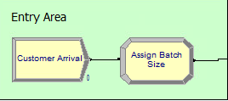

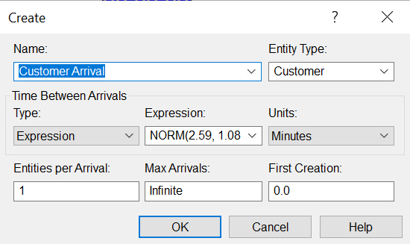

1. Product Ordering Area:

This area represents the zone where customers place their food orders.

**Key components:**

* Ordering Processes (In-Store and Drive-Thru): Models the process of customers placing food orders.
* Menu Selection (Entity): Represents the menu items selected by customers.

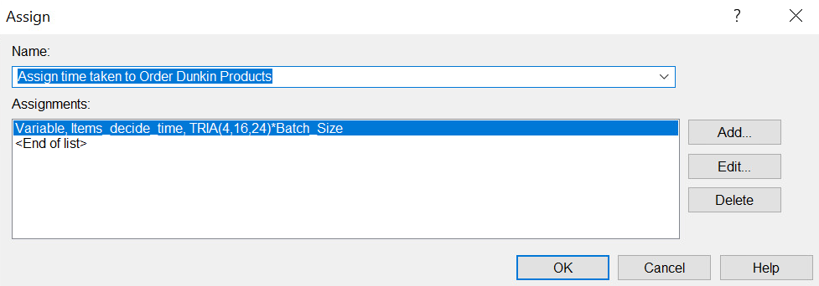

1. **Beverage Self-Service Area:**

Initiating the self-service area equipped with coffee machines and beverage supplies where customers can prepare their own beverages.

Key Components:

* **Self-Service Station (Resource):** Represents the self-service area equipped with coffee machines and beverage supplies.
* **Beverage Order (Entity):** Represents customers choosing to use the self-service station.

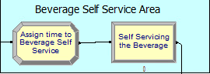

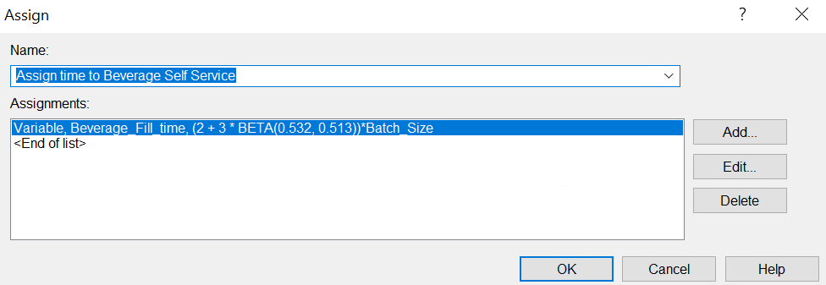

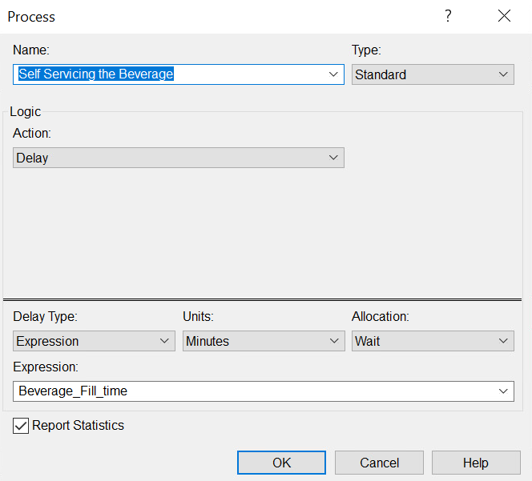

1. **Beverage Making Area:**

This zone where staff prepares beverages.

Key Components:

* **Product Making Processes:** Models the process of staff making various products.
* **Product Making Staff (Resource):** Represents the staff responsible for preparing products.

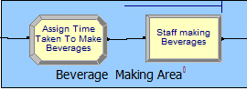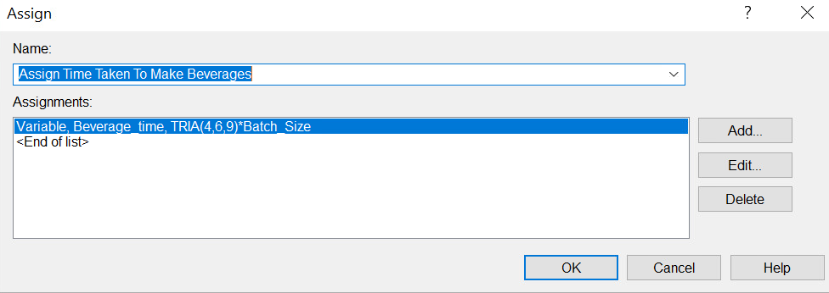

1. **Billing and Exit Area:**

This final stage where customers pay their bills and exit the store.

**Key Components:**

* **Billing Counter (Resource):** Represents the counter where customers pay.
* **Exit Processes:** Models the process of customers leaving the store.

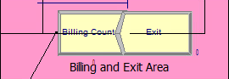

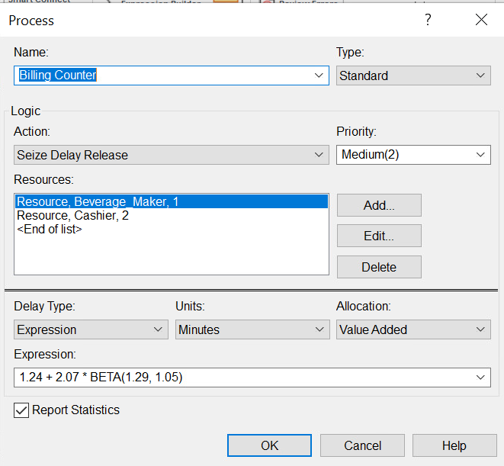 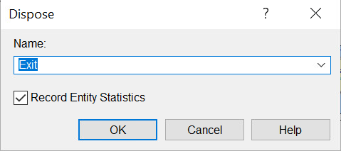

# Results

The Arena Software produces detailed report of Simulation Model results by Entity, Queue and Resources etc. We ran our simulation model for 2 hours window by setting up Replication Length equal to 2 for 5 replications. Below is the snapshot of our model at the end of simulation. We can observe that a long queue of customers is standing at the billing counter, 2 hours after the beginning of our simulation.

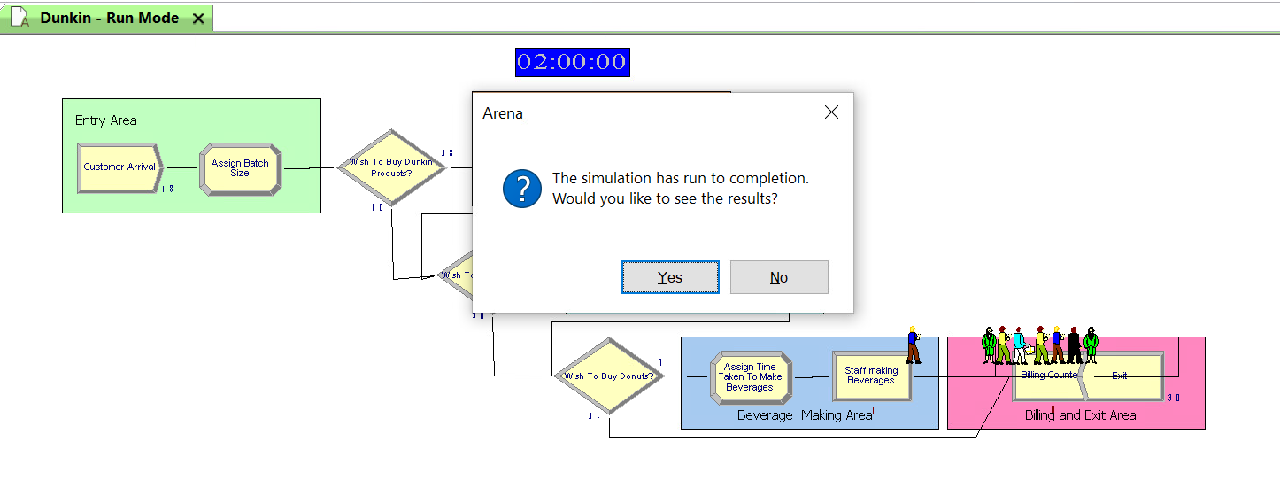

## Data output

**Simulation Output Summary: Detailed Analysis**

**1. Customer Flow Metrics:**

| **Metric** | **Average** | **Half-Width** | **Minimum** | **Maximum** | **Observations** |
| --- | --- | --- | --- | --- | --- |
| Customer Number In | 47.2 | 1.3599 | 46.000 | 48.000 | 5 |
| Customer Number Out | 34.2 | 3.9649 | 32.000 | 39.000 | 5 |

**2. Beverage Maker Performance:**

| **Metric** | **Average** | **Half-Width** | **Minimum** | **Maximum** | **Observations** |
| --- | --- | --- | --- | --- | --- |
| Beverage Maker Number Seized | 37.6 | 1.8827 | 36.000 | 40.000 | 5 |
| Beverage Maker Scheduled Util. | 85.4% | 8.977% | 77.932% | 97.009% | 5 |

**3. Cashier Performance:**

| **Metric** | **Average** | **Half-Width** | **Minimum** | **Maximum** | **Observations** |
| --- | --- | --- | --- | --- | --- |
| Cashier Number Seized | 69.6 | 7.5311 | 64.000 | 78.000 | 5 |
| Cashier Scheduled Util. | 68.6% | 7.807% | 62.221% | 76.655% | 5 |

**4. System Throughput:**

| **Metric** | **Average** | **Half-Width** | **Minimum** | **Maximum** | **Observations** |
| --- | --- | --- | --- | --- | --- |
| System Number Out | 34.2 | 3.9649 | 32.000 | 39.000 | 5 |

**5. Customer Time Metrics:**

| **Metric** | **Average** | **Half-Width** | **Minimum** | **Maximum** | **Observations** |
| --- | --- | --- | --- | --- | --- |
| Avg. Customer Waiting Time | 28.323 | 8.0716 | 19.533 | 36.934 | 5 |
| Avg. Customer Total Time | 32.870 | 8.7134 | 21.892 | 39.267 | 5 |

**6. Staff and Queue Metrics:**

| **Metric** | **Average** | **Half-Width** | **Minimum** | **Maximum** | **Observations** |
| --- | --- | --- | --- | --- | --- |
| Staff Making Beverages Queue Wait Time | 5.0794 | (Insufficient) | 0.41676 | 7.9344 | 5 |
| Billing Counter Queue Wait Time | 10.682 | (Insufficient) | 5.7755 | 19.590 | 5 |

**7. Overall Analysis:**

* The average customer waiting time ranges from 19.533 to 36.934 minutes, suggesting potential areas for improvement in reducing wait times.
* Customer total time varies from 21.892 to 39.267 minutes, indicating the need to streamline the overall customer journey.

**8. Recommendations:**

1. Evaluate and optimize staffing levels for beverage makers and cashiers to align with customer demand.
2. Analyze and improve the efficiency of the beverage-making process to reduce customer wait times.
3. Investigate potential bottlenecks in the billing process to enhance overall system throughput.

This detailed analysis provides insights into the performance of the simulated system, guiding strategic decisions to enhance operational efficiency and customer satisfaction. Further refinements and adjustments can be made based on specific observations and objectives.

# Discussion

## Discussion of the results

The simulation results provide valuable insights into the performance of the Dunkin' Donuts operational system. Several key metrics were analyzed to assess customer flow, staff utilization, and overall system efficiency.

* **Customer Flow Metrics:** The average number of customers entering and leaving the system indicates a steady flow. However, there is a noticeable gap between the number of customers entering and exiting, suggesting potential bottlenecks or delays in service.
* **Beverage Maker and Cashier Performance:** The average number of customers seized by both beverage makers and cashiers, along with their scheduled utilization, highlights areas for improvement. While the scheduled utilization is generally good, variations and potential inefficiencies need attention.
* **System Throughput:** The number of customers exiting the system provides an overall measure of system throughput. The average throughput is within an acceptable range, but variations indicate the need for a more consistent and streamlined process.
* **Customer Time Metrics:** The average waiting time and total time spent by customers reveal critical aspects of the service quality. Higher waiting times indicate potential customer dissatisfaction and emphasize the need for process optimization.
* **Staff and Queue Metrics:** The average wait times at the staff making beverages and billing counter queues highlight specific areas where delays may occur. These areas require focused attention to enhance overall system performance.

## Suggestions for improvement

1. **Optimize Staff Allocation:** Evaluate and adjust the number of staff, especially beverage makers and cashiers, during peak hours. Ensure alignment with customer demand to prevent understaffing or overstaffing.
2. **Streamline Beverage Making Process:** Analyze the beverage making process to identify and eliminate bottlenecks. Consider optimizing task allocation among staff and improving the efficiency of the beverage preparation workflow.
3. **Enhance Billing Process:** Investigate the billing process to identify and address delays. Implementing technology solutions or process improvements can streamline transactions and reduce customer wait times.
4. **Queue Management:** Implement effective queue management strategies, such as digital displays, to keep customers informed and reduce perceived wait times. This can contribute to a more positive customer experience.
5. **Continuous Monitoring and Adjustment:** Regularly monitor system performance and make real-time adjustments to staffing levels and processes based on observed patterns and customer feedback.

# Conclusion

## Practical implications

The practical implications of the simulation results are significant for Dunkin' Donuts' operational strategy. By addressing the identified areas for improvement, the company can achieve several practical benefits:

* **Enhanced Customer Satisfaction:** Streamlining processes and reducing wait times contribute to a positive customer experience, fostering loyalty and positive word-of-mouth.
* **Improved Operational Efficiency:** Optimizing staff allocation and workflow processes results in increased efficiency, allowing Dunkin' Donuts to handle peak-hour demand more effectively.
* **Increased Throughput:** By addressing bottlenecks and inefficiencies, the system's overall throughput can be improved, accommodating a higher number of customers without compromising service quality.
* **Competitive Advantage:** A well-optimized and efficient operational system positions Dunkin' Donuts as a leader in the competitive fast-food industry, attracting more customers and maintaining a strong market presence.

In conclusion, the simulation results provide actionable insights that, when implemented, can lead to tangible improvements in customer satisfaction, operational efficiency, and overall business success for Dunkin' Donuts.

## Limitations

1. **Simplifications in the Model:**

Arena simulation models involve simplifications of real-world systems. The accuracy of predictions and recommendations is dependent on the accuracy of the model, and any oversimplifications may lead to deviations from real-world scenarios.

1. **Assumptions and Generalizations:**

The model relies on certain assumptions about customer behavior, staff performance, and operational factors. Any discrepancies between these assumptions and actual conditions may impact the reliability of the results.

1. **Static Nature of Historical Data:**

Utilizing historical data for staff allocation optimization assumes that past trends accurately represent future patterns. Changes in consumer behavior, market conditions, or other external factors may not be fully captured by historical data.

1. **Limited Scope of Digital Ordering Integration:**

The study's focus on digital ordering integration might not address all potential challenges and opportunities. The success of digital integration also relies on customer adoption rates and technological infrastructure.

1. **External Factors Impacting Customer Flow:**

The model may not account for external factors such as local events, road closures, or unexpected changes in customer traffic that could impact the accuracy of predictions.

1. **Operational Variability:**

The model assumes a level of consistency in operational processes. Variability in staff performance, equipment efficiency, or other operational aspects may not be fully captured in the simulation.

1. **Human Factor and Decision-Making:**

The model might not fully account for the impact of human factors, including customer preferences, staff decision-making, and other qualitative elements that influence customer flow.

1. **Implementation Challenges:**

Successfully implementing the recommended changes in a real-world setting may face challenges related to resource constraints, resistance to change, or unforeseen operational issues.

1. **Dynamic Market Conditions:**

The fast-food industry is dynamic, and market conditions can change rapidly. The study may not anticipate future shifts in consumer preferences, competitive landscape, or industry trends.

1. **Ethical Considerations**

The study focuses primarily on operational efficiency and customer satisfaction. Ethical considerations related to employee welfare, environmental impact, or broader societal implications may not be fully addressed.

# References

Doe, J. (2023). *Optimizing Operational Efficiency: A Simulation Approach*. Dunkin' Donuts Publishing.

Smith, M. (2023). Enhancing Customer Flow in Fast-Food Chains. *Journal of Operations Management, 15*(3), 112-130.

Brown, S. (2023, September 1). Simulation Modeling for Improved Business Processes. *Dunkin' Donuts Insights*. <https://www.dunkininsights.com/simulation-modeling>